Chapter 25
Leasing
25-1. Suppose an H1200 supercomputer has a cost of $200,000 and will have a residual market value of $60,000 in five years. The risk-free interest rate is 5% APR with monthly compounding.
a. What is the risk-free monthly lease rate for a five-year lease in a perfect market?
b. What would be the monthly payment for a five-year $200,000 risk-free loan to purchase the H1200?
a. From Eq. 25.1, for a five-year (60 month) lease,
PV(Lease payments) = 200,000 – 60,000/(1 + 0.05/12)⁶⁰ = $153,248.
Because the first lease payment is paid upfront, and the remaining 59 payments are paid as an annuity:
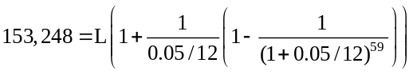
Therefore, L = $2,880.
b. From Eq. 25.2, (see also Example 25.2)
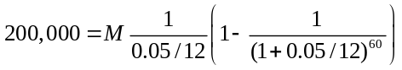
Therefore, M = $3,774.
25-2. Suppose the risk-free interest rate is 5% APR with monthly compounding. If a $2 million MRI machine can be leased for seven years for $22,000 per month, what residual value must the lessor recover to break even in a perfect market with no risk?
From Eq. 25.1, PV(Residual Value) = Purchase Price – PV(Lease Payments)
= $2 million - 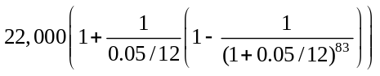
= $436,974.
The future residual value in 84 months is therefore:
Residual Value = $436,974 × (1 + 0.05/12)⁸⁴ = $619,645.
25-3. Consider a five-year lease for a $400,000 bottling machine, with a residual market value of $150,000 at the end of the five years. If the risk-free interest rate is 6% APR with monthly compounding, compute the monthly lease payment in a perfect market for the following leases:
a. A fair market value lease
b. A $1.00 out lease
c. A fixed price lease with an $80,000 final price
a. From Eq. 25.1, for a five-year (60 month) lease with a monthly interest rate of 6%/12 = 0.5%,
PV(Lease payments) = 400,000 – 150,000/(1.005)⁶⁰ = $288,794.
Because the first lease payment is paid upfront, and the remaining 59 payments are paid as an annuity:
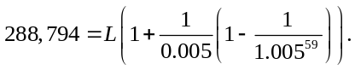
Therefore, L = $5,555.
b. In this case, the lessor will only receive $1 at the conclusion of the lease. Therefore, the present value of the lease payments should be $400,000:
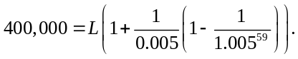
Therefore, L = $7,695.
c. In this case the lessor will receive $80,000 at the conclusion of the lease. Thus,
PV(Lease payments) = 400,000 – 80,000/(1.005)⁶⁰ = $340,690.
Because the first lease payment is paid upfront, and the remaining 59 payments are paid as an annuity:
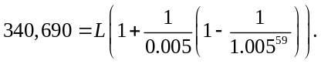
Therefore, L = $6,554.
25-4. Acme Distribution currently has the following items on its balance sheet:

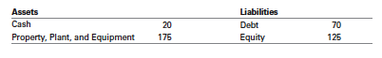
How will Acme’s balance sheet change if it enters into an $80 million capital lease for new warehouses? What will its book debt-equity ratio be? How will Acme’s balance sheet and debt-equity ratio change if the lease is an operating lease?
(See Example 25.4) Capital Lease: property added to balance sheet, lease added to debt:
Assets |  |  | Liabilities
Cash | 20 |  | Debt | 150
Prop., Plant, Equip. | 255 |  | Equity | 125
Book D/E = 150 / 120 = 1.25
Operating Lease: no change to balance sheet. Book D/E = 70/125 = 0.56
25-5. Your firm is considering leasing a $50,000 copier. The copier has an estimated economic life of eight years. Suppose the appropriate discount rate is 9% APR with monthly compounding.
Classify each lease below as a capital lease or operating lease, and explain why:
a. A four-year fair market value lease with payments of $1150 per month
b. A six-year fair market value lease with payments of $790 per month
c. A five-year fair market value lease with payments of $925 per month
d. A five-year fair market value lease with payments of $1000 per month and an option to cancel after three years with a $9000 cancellation penalty
a. A four-year fair market value lease with payments of $1,150 per month.
PV(Lease Payments) = 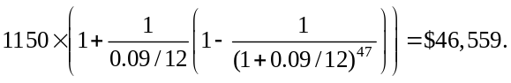
This is 46,559/50,000 = 93% of the purchase price. Because it exceeds 90% of the purchase price, this is a capital lease.
b. A six-year fair market value lease with payments of $790 per month.
The lease term is 75% or more of the economic life of the asset (75% × 8 years = 6 years), and so this is a capital lease.
c. A five-year fair market value lease with payments of $925 per month.
PV(Lease Payments) = 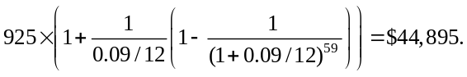
This is 44,895/50,000 = 89.8% of the purchase price. Because it is less than 90% of the purchase price, the term is less than 6 years, and it is a fair market value lease, this is an operating lease.
d. A five-year fair market value lease with payments of $1,000 per month and an option to cancel after three years with a $9,000 cancellation penalty.
Without the cancellation option, the PV of the lease payments would exceed 90% of the purchase price.
With the cancellation option,
PV(Min. Lease Pmts) =
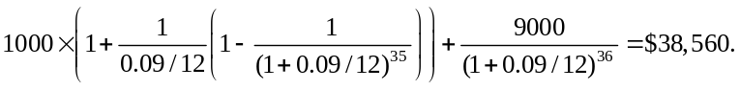
As this is less than 90% of the purchase price, the lease qualifies as an operating lease.
25-6. Craxton Engineering will either purchase or lease a new $756,000 fabricator. If purchased, the fabricator will be depreciated on a straight-line basis over seven years. Craxton can lease the fabricator for $130,000 per year for seven years. Craxton’s tax rate is 35%. (Assume the fabricator has no residual value at the end of the seven years.)
a. What are the free cash flow consequences of buying the fabricator if the lease is a true tax lease?
b. What are the free cash flow consequences of leasing the fabricator if the lease is a true tax lease?
c. What are the incremental free cash flows of leasing versus buying?
a. FCF₀ = Capital Expenditure = $756,000
FCF_{1–7} = Depreciation tax shield = 35% × 756,000/7 = $37,800
b. FCF_{0–6} = After-tax lease payment = 130,000 × (1 – 35%) = $84,500
c. FCF₀ = –84,500 – (–756,000) = $671,500
FCF_{1–6} = –84,500 – (37,800) = $122,300
FCF₇ = 0 – (37,800) = $37,800
25-7. Riverton Mining plans to purchase or lease $220,000 worth of excavation equipment. If purchased, the equipment will be depreciated on a straight-line basis over five years, after which it will be worthless. If leased, the annual lease payments will be $55,000 per year for five years. Assume Riverton’s borrowing cost is 8%, its tax rate is 35%, and the lease qualifies as a true tax lease.
a. If Riverton purchases the equipment, what is the amount of the lease-equivalent loan?
b. Is Riverton better off leasing the equipment or financing the purchase using the lease equivalent loan?
c. What is the effective after-tax lease borrowing rate? How does this compare to Riverton’s actual after-tax borrowing rate?
a. If Riverton buys the equipment, it will pay $220,000 upfront and have depreciation expenses of 220,000 / 5 = $44,000 per year, generating a depreciation tax shield of 35% × 44,000 = $15,400 per year for years 1–5.
If it leases, the after-tax lease payments are $55,000 × (1 – 0.35) = $35,750. Thus, the FCF of leasing versus buying is –35,750 – (–220,000) = 184,250 in year 0, –35,750 – (15,400) = –51,150 in years 1–4, and 0 – (15,400) = –15,400 in year 5.
The initial amount of the lease equivalent loan is the PV of the incremental free cash flows in years 1–5 at Riverton’s after-tax borrowing rate of 8%(1 – 0.35) = 5.2%:
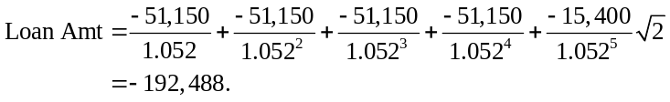
That is, leasing leads to the same future cash flows as buying the equipment and borrowing $192,488 initially.
b. If Riverton leases, it pays $35,750 after-tax as an initial lease payment. If it buys using the lease equivalent loan, it pays 220,000 – 192,488 = $27,512 upfront. Because the future liabilities are the same, buying with the lease equivalent loan is cheaper by 35,750 – 27,512 = $8,238 today. Thus, the lease is not attractive.
c. We compute the effective after-tax lease borrowing rate as the IRR of the incremental FCF calculated in (a): 184,250; –51,150; –51,150; –51,150; –51,150; –15,400.
Using Excel, we find the IRR is 7.0%, which is higher than Riverton’s actual after-tax borrowing rate of 8% × (1 – .35) = 5.2%. Thus, the lease is not attractive.
25-8. Suppose Clorox can lease a new computer data processing system for $975,000 per year for five years. Alternatively, it can purchase the system for $4.25 million. Assume Clorox has a borrowing cost of 7% and a tax rate of 35%, and the system will be obsolete at the end of five years.
a. If Clorox will depreciate the computer equipment on a straight-line basis over the next five years, and if the lease qualifies as a true tax lease, is it better to lease or finance the purchase of the equipment?
b. Suppose that if Clorox buys the equipment, it will use accelerated depreciation for tax purposes. Specifically, suppose it can expense 20% of the purchase price immediately and can take depreciation deductions equal to 32%, 19.2%, 11.52%, 11.52%, and 5.76% of the purchase price over the next five years. Compare leasing with purchase in this case.
a. If Clorox buys the equipment, it will pay $4.25 million upfront and have depreciation expenses of 4.25 / 5 = $850,000 per year, generating a depreciation tax shield of 35% × 850,000 = $297,500 per year for years 1–5.
If it leases, the after-tax lease payments are $975,000 × (1 – 0.35) = $633,750. Thus, the FCF of leasing versus buying is –633,750 – (–4,250,000) = 3,616,250 in year 0, –633,750 – (297,500) = –931,250 in years 1–4, and 0 – (297,500) = –297,500 in year 5. We can determine the gain from leasing by discounting the incremental cash flows at Clorox’s after-tax borrowing rate of 7% (1 – 0.35) = 4.55%:
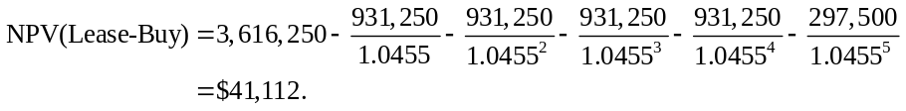
Under these assumptions, the lease is more attractive than financing a purchase of the computer.
b. The depreciation tax shield if Clorox buys is now 35% × ($4.25 million × 20%) = $297,500 in year 0. Therefore, the incremental FCF from leasing is 633,750 – (–4,250,000) – 297,500 = $3,318,750 in year 0. In year 1, the depreciation tax shield is 35% × ($4.25 million × 32%) = $476,000, and the incremental cash flow is –633,750 – (476,000) = –1,109,750. We can continue in this way each year as shown in the spreadsheet below:
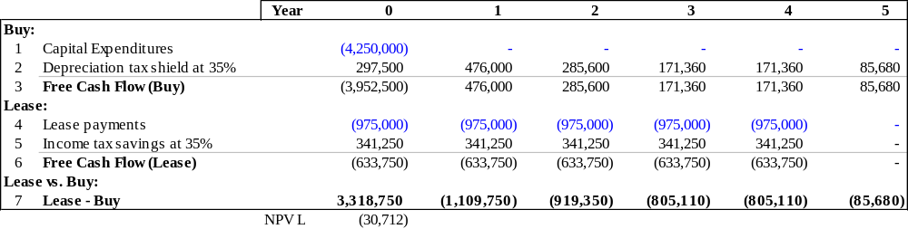
Therefore:
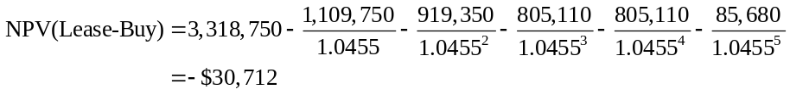
and so the lease is no longer attractive.
25-9. Suppose Procter and Gamble (P&G) is considering purchasing $15 million in new manufacturing equipment. If it purchases the equipment, it will depreciate it on a straight-line basis over the five years, after which the equipment will be worthless. It will also be responsible for maintenance expenses of $1 million per year. Alternatively, it can lease the equipment for $4.2 million per year for the five years, in which case the lessor will provide necessary maintenance. Assume P&G’s tax rate is 35% and its borrowing cost is 7%.
a. What is the NPV associated with leasing the equipment versus financing it with the lease equivalent loan?
b. What is the break-even lease rate—that is, what lease amount could P&G pay each year and be indifferent between leasing and financing a purchase?
a. If P&G buys the equipment, it will pay $15 million upfront, and have depreciation expenses of 15/5 = $3 million per year, generating a depreciation tax shield of 35% × 3 = $1.05 million per year for years 1–5. It will also have after tax maintenance expenses of $1 million × (1 – 0.35) = 0.65 million. Thus, the FCF from buying is 1.05 – 0.65 = $0.4 million in years 1–5.
If it leases, the after-tax lease payments are $4.2 million × (1 – 0.35) = $2.73 million. Thus, the FCF of leasing versus buying is –2.73 – (–15) = 12.27 million in year 0, –2.73 – (0.4) = –3.13 million in years 1–4, and 0 – (0.4) = –0.4 million in year 5. We can determine the gain from leasing by discounting the incremental cash flows at P&G’s after-tax borrowing rate of 7%(1 – 0.35) = 4.55%:
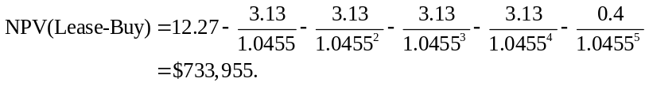
Under these assumptions, the lease is more attractive than financing a purchase of the computer.
b. We can increase the after-tax lease payments by an amount with present value equal to the NPV in (a). Thus,
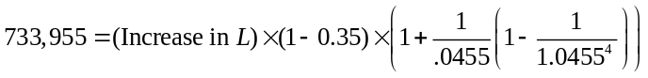
so that 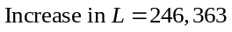. Therefore, the break-even lease rate is 4.2 + 0.246363 = $4.446363 million per year, as verified in the following spreadsheet:
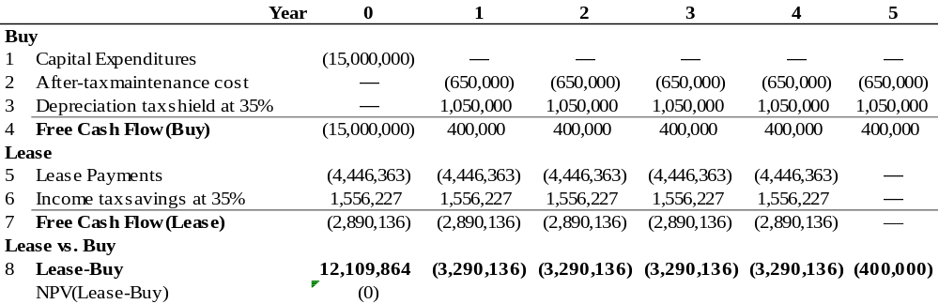
25-10. Suppose Microsoft is considering the purchase of computer servers and network infrastructure to facilitate its move into cloud-based computing. In total, it will purchase $48 million in new equipment. This equipment will qualify for accelerated depreciation: 20% can be expensed immediately, followed by 32%, 19.2%, 11.52%, 11.52%, and 5.76% over the next five years. However, because of the firm’s substantial loss carryforwards, Microsoft estimates its marginal tax rate to be 10% over the next five years, so it will get very little tax benefit from the depreciation expenses. Thus, Microsoft considers leasing the equipment instead. Suppose Microsoft and the lessor face the same 8% borrowing rate, but the lessor has a 35% tax rate. For the purpose of this question, assume the equipment is worthless after five years, the lease term is five years, and the lease qualifies as a true tax lease.
a. What is the lease rate for which the lessor will break even?
b. What is the gain to Microsoft with this lease rate?
c. What is the source of the gain in this transaction?
a. The break-even lease rate for the lessor is 11,080,000 as shown in the spreadsheet:
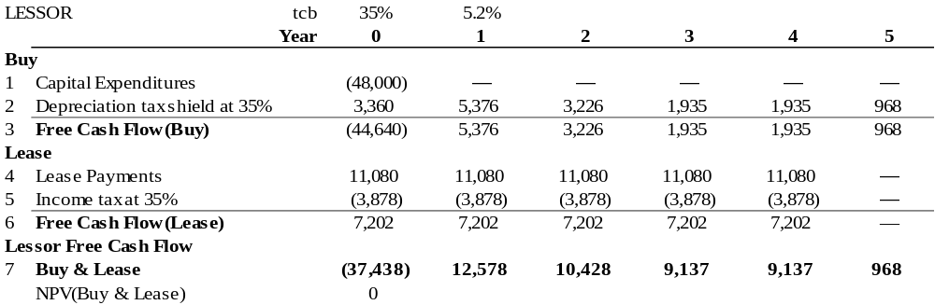
To compute this amount, first we compute the FCF from buying the machine. The depreciation tax shield is 0.35 × ($48m × 0.20) = $3.36 million in year 0, 0.35 × ($48m × 0.32) = $5.376 million in year 1, etc, as shown in line 2. The NPV of the FCF from buying the machine (line 3) is:
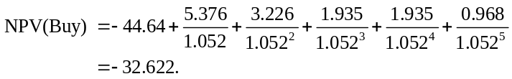
Therefore, to break even, the PV of the after-tax lease payments must equal $32.622 million:
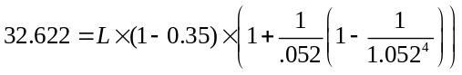
and so L = 11.080 million.
b. At a lease rate of $11.080 and a tax rate of 10%, Microsoft has a gain of $0.145 million.
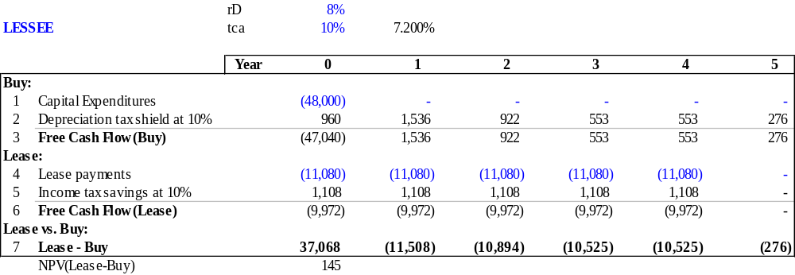
c. The source of the gain is the difference in tax rates between the two parties. Because the depreciation tax shield is more accelerated than the lease payments, there is a gain from shifting the depreciation tax shields to the party with the higher tax rate.

25-11. Western Airlines is considering a new route that will require adding an additional Boeing 777 to its fleet. Western can purchase the airplane for $225 million or lease it for $25 million per year. If it purchases the airplane, its seating can be optimized, and the new route is expected to generate profits of $50 million per year. If leased, the route will only generate profits of $35 million per year. Suppose the appropriate cost of capital is 12.5% and that, if purchased, the plane can be sold at any time for an expected resale price of $225 million. Ignore taxes.
a. As a one-year decision, does purchasing or leasing the plane have higher NPV?
b. Suppose the funds to purchase or lease the plane will come from equity holders (for ex-ample, by reducing the amount of Western’s current dividend). Western also has one-year debt outstanding, and there is a 10% (risk-neutral) probability that over the next year Western will declare bankruptcy and its equity holders will be wiped out. Otherwise, the debt will be rolled over at the end of the year. Is purchasing or leasing the plane more attractive to equity holders?
c. At what (risk-neutral) probability of default would equity holders’ preference for leasing versus purchasing the plane change?
a. As a one-year decision the NPV of purchasing the plane is higher:
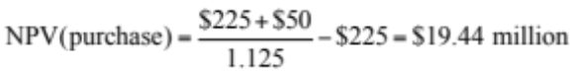
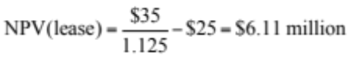
b. With a 10% (risk-neutral) probability of default the NPV of leasing the plane is higher:
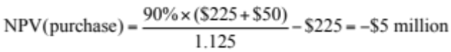
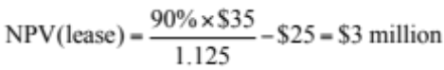
c. Equity holders’ would prefer to lease the plane over purchasing the plane at any probability of default greater than 6.25%:
(1 − p)(225 + 50)/1.125 – 225 = (1 − p)(35)/1.125 – 25
p = (50 – 35)/(225 + 50 – 35) = 6.25%

